UNIT-2 ELECTRIC HEATING

INTRODUCTION:

When current is passed through a conductor, it gets heated up due to I²R losses and this heating characteristic of the electric current is being utilized in industrial and domestic appliances.

Heating is required for domestic purposes such as cooking and heating of buildings whereas for industrial purposes and heating is required for melting of metals , hardening and tempering and in welding.

Advantages of electric heating over other systems of heating :

The main advantages of electric heating over other systems of heating (i.e coal, gas, or oil) heating are:

- Economical: Electric heating is economical as electric furnaces are cheaper in initial cost as well as maintenance cost. It does not require any attention so there is a considerable saving in labour cost over other systems of heating. moreover, the electric energy is also cheap as it is produced on large scale.

- Cleanliness: Since dust and ash are completely eliminated in electric heatingsystem, so it is clean system and cleaning costs are rendered to a minimum.

- Absence of fuel gases: Since no fuel gases are produced in this system, the atmosphere around is clean and pollution free.

- Ease of control: Simple, accurate and reliable temperature of a furnace can be had with the help of manual or automatic devices. Desired temperature can be had in electric heating system which is not convenient in other heating systems.

- Efficiency: It has been practically found that 75 to 100% of heat produced by electric heating can be successfully utilized as the source can be brought directly to the point where heat is required there by reducing the losses.

- Automatic protection: Automatic protection against over currents or overheating can be provided through suitable switchgears in electric heating systems.

- Better working conditions: Electric heating system produces no irritation noise and also the radiation losses are low. Thus working with electric furnaces is convenient and cool.

- Safety: Electric heating is quite safe and responds quickly.

- Upper limit temperature: There is no upper limit to the temperature obtainable except the ability of the material to with stand heat.

- Special heating requirements: Certain requirements of heating such as uniform heating of material or heating of one particular portion of the job without effectingothers,
heating of non-conducting materials, heating with no oxidation can be met only in electric heating system.

Heating element:

The heating effect of electric current can be produced by passing electric current through Heating element and the material used for heating element must have fallowing properties
- It should have high specific resistance so that a small length of wire (R = , p = ) is sufficient to produce the required amount of heat.
- It should have high melting point so that high temperature can be obtained.
- It should have low temperature co-efficient since for accurate temperature control, the resistance should be nearly constant at all temperature and this is possible only if the resistance does not change with temperature.
- It should not oxidize at higher temperatures otherwise its life is shortened andneeds frequent replacement.

The most commonly used heating elements are either alloy of nickel and chromium or nickel-chromium iron, nickel-chromium-aluminium, nickel-copper. The use of iron reduces the cost but lowers the life of the element.

Design of Heating Element:

The heating element used for electric heating may be circular or rectangular like a ribbon but ribbon type of element requires more wattage per unit area. Hence circular heating elements are preferred.

By knowing the electrical input and its voltage the size and length of the heating element required to produce given temperature can be calculated.

Causes of failure of heating element

There are so many causes are there for the failure of heating element. Some of them are explained below.

- Formation of Hot Spots: Hot spots are the points in heating element which are at higher temperature than the main body of the element. Hot spots may be due to any of the fallowing causes:

  - High rate of local oxidation may reduce the cross-section of the element wire thereby increasing the resistance at that spot. Thus more heat will be produced locally giving rise to the breakdown of the element.
  - Shielding of element by supports etc. will reduce the local heat loss by radiation and causes a rise of temperature of shielded portion of the element therefore minimum number of supports without producing distortion of the element should be used.
  - Due to too high element temperatures, insufficient support for the element or selection of wrong material, sagging and wrapping of element may result which may causes uneven spacing of sections there by producing hot spots.

- Oxidation of intermittency of operation: At high temperature, oxide scale is formed on the heating element which is continuous and tenacious and is so string that it prevents further oxidation of inner metal of element. However, if the element used quite often the oxide layer is subjected to thermal stresses due to frequent cooling and heating thereby the oxide layer cracks and flakes off exposing further fresh metal to oxidation thereby producing hot spots.
- Embrittlement due to grain, growth: All heating alloys containing iron, tend to form large brittle grains at high temperatures. When cold the elements are very brittle and liable to rupture easily on slightest handling and jerks.
- Contamination and corrosion: Elements may be subjected to dry corrosion produced by their contamination with the gases of controlled atmosphere prevailing in annealing furnaces or fumes from flux used in brazing furnaces or oil fumes produced by heat treatment of components contaminated with lubricant.

Modes of Transfer of Heat:

The heat from one body to another body can be transferred by any one of the fallowing methods.

1. Conduction 2. Convection 3. Radiation

Conduction:
In this method, heat travels without the actual movement of practices (molecules). The flow of heat from one part of the body to other part is dependent upon the temperature differences between these parts. It is also applicable when two bodies at different temperatures are joined together. The heated molecules of the substances transfer their heat to the adjacent molecules and this heat flow will invariably take place so long as there is difference in temperature.

For example when one end of solid is heated, the molecules at that end absorb the heat energy and begin to vibrate rapidly when these molecules collide with neighboring molecules, some energy is passed them with in turn begin to vibrate faster and pass some energy to their molecules. Thus heat is transferred from one molecule to another molecule without their actual movement.

If the heat is to be conducted from one object to another object, the fallowing conditions must be met.

  - The objects should be bodily in contact with each other.
  - The temperature of the two bodies should be different i.e. temperature gradient should exixt.
Definition of conduction: The process in which heat is transferred from one particle to another in direction of fall of temperature without the actual movement of particles of medium is called conduction.
The rate of conduction of heat along a substance depends upon the temperature gradient and is expressed in Mj/hr/m²/m/c⁰ or in watts/cm² in case of electric heating.
In a plate of thickness t meters having X-sectional area of its two parallel feces A sq.meters and temperature of two faces is T₁ and T₂ absolute, the quantity of heat transferred through it during T hours is given by

Q = (T₁ – T₂) T

Where K is coefficient of thermal conductivity for material in Mj/hr/m²/m/c⁰

Convection:

Def: The process of heat transference in which heat is transferred from one place to another (from hotter to colder one) by actual movement of particles of medium is calles convection.
For example in case of heater used for heating buildings, the air in contact with a heat radiator element in a room receives heat from contact with the element. The heated air expands and rises, cold air flowing into takes place. Thus there is a constant flow of air upwards across the heating elements. Thus in this way the room gets heated up.
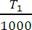
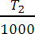

A similar action takes place in an electric water heater, a continuous floe of water passing upwards across the immersed heating element, with the result that the whole of the water in the tank becomes hot.
The quantity of heat absorbed from the heater by convection depends mainlyupon the temperature of the heating element above the surroundings and upon the size of surface of the heater. It also depends partly on the portion of the heater.

Heat dissipation is given by the fallowing expression

H = a (T₁ – T₂) b w/m²
Where a, b - constants whose values depends on the heating surface facilities for heating etc.
T₁, T₂- temparture of the heating surface and fluid in ⁰c.

Radiation:
Def: The process of transmission of heat in which heat energy is transferred from hotter body to colder body without heating the medium in between is called radiation.
Foe example we receive energy from the sun by radiation through there in distance of about 150 million Kms between sun and earth.
Rate of heat radiation is given by stefan’s law according to which: Heat dissipation H = 5.72× 104 Ke –
Where - temperature of source of heat in ⁰c

- temperature of substance to be heated in ⁰c

K – constant known as radiant efficiency whose value is 1 for single element and 0.5 to 0.8 for several elements placed by side by side.
e – emissivity which is 1 for black body. And 0.9 for resistance heating elements.

Electric heating methods:
Electric heating methods can be classified as:

Electric heating

Power frequency heating high frequency heating

Arc heating Resistance heating Induction heating dielectric heating

Direct arc heating

Direct resistance heating Indirect resistance heating Infrared heating Indirect arc heating

ARC HEATING:
When a high voltage is applied across in air gap, the air in the gap gets ionized under electrostatic forces and become conducting medium. Current flows in the form of a continuous spark called the arc. A very high voltage is required to establish an arc across the air gap but to maintain an arc small voltage should be sufficient.
Alternatively an arc can also be produced by short circuiting the two electrodes momentarily and then withdrawing them back. Arc between the two electrodes produces heat and has a temperature between 1000 ⁰c and 3500 ⁰c depending upon the material of electrodes used. The use of this principle may be in electric arc furnace.
Usually arc furnaces are of cylindrical shape but recently conical shaped shells have been used due to the advantage of a large surface area per unit volume. Moreover the conical shaped furnace consumes less power, radiation loss and melting time is also reduced.
The arc chamber of the furnace consists of a suitable acid or basic refractory lining supported on a metal frame. Each furnace is provided with charging door and tap hole for introducing the charge and taking out the molten metal. The electrodes project through the top or sides of chamber and are arranged for easy replacement and adjustment. The electrodes used in arc furnace are either made of carbon or graphite. Graphite is mostly preferred however carbon electrodes are used with small furnaces.

The salient points of the two types of electrodes are:
  - Resistance: owing to lower resistivity of graphite the size of graphite electrode is reduced to half of the carbon electrode for the same current carrying thus facilitating easy replacement.

  - Consumption: graphite begins to oxidize at about 600⁰c whereas carbon at about 400⁰c and thus consumption of graphite electrode is about one half of carbon elevtrode.
  - Evenness of heating: The larger area of carbon electrodes means a greater surface area of charge covered by the arc and consequently a more uniform distribution of heat, on the other hand however the arc is brought nearer to the side of furnaces which tend to shorten the life of refractor lining.
  - Cost: Graphite electrodes cost about twice as much per Kg as carbon electrodes so that the savings due to their use largely nullified especially if the process is one in which the electrode consumption is large.
The choice between the two types of electrodes depends upon the application however in general for processes requiring large quantities of electrodes, the carbon electrode is used.

Types of furnaces:
Arc furnaces may be classifies into two types.
- Direct arc furnace.
- Indirect arc furnace.

Direct arc furnace:
In this type of furnace, the arc is formed between the electrodes and the charge as shown in figure 1. In this type of furnace, charge acts as another electrode. There are two carbon or graphite electrodes and the arc is developed at two places.
Since in direct arc furnace, the arc is in direct contact with the charge and heat is also produced by current flowing through the charge itself, the can therefore be heated to highest temperature.
In case of single phase arc furnace, two electrodes are taken vertically downward through the roof of furnace to the surface of charge whereas in case of three phase arc furnace three electrodes put at the corners of an equivalent triangle are used which produces three arcs, the charge itself thus forms a star point.
The most common application of this type of furnace is for production of steel. This is advantageous as compared to cupola method for production of steel due to the fallowing reasons.
  - By using this method, purer product can be obtained as referring process can be easily controlled.
  - Arc furnace can operate on 100% steel scrap which is cheaper than pig iron whereas cupola requires a proportion of pig iron in cupola charge.
This is the reason, direct arc furnace even being costlier in initial as well as operating costs is preferred.

Indirect arc fuarnace:
In this type of furnace, the arc is formed between two electrodes above the charge and the heat is transmitted to the charge solely by radiation as shown in figure 2.
The temperature of the charge in the indirect-arc furnace is lower than in the direct-arc
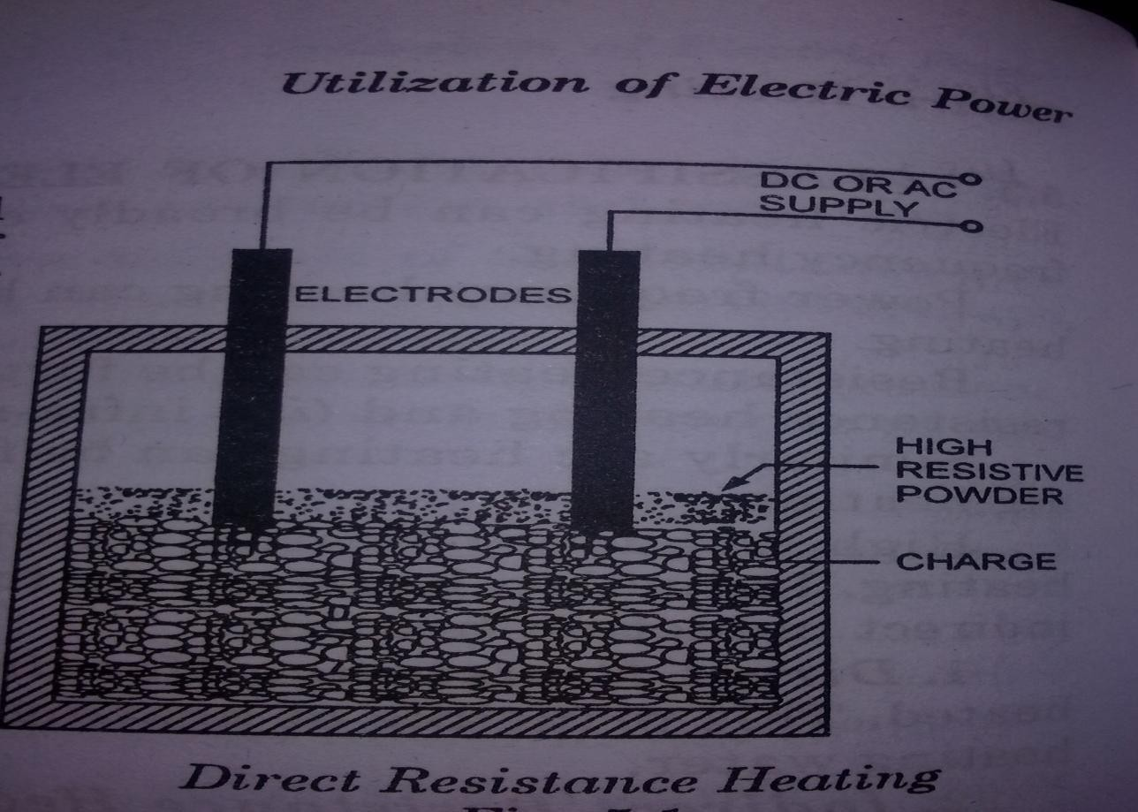
furnace, since heat is transmitted to it solely by radiation. As no current flows through the charge there is no inherent stirring action, and the furnace must be rocked mechanically; for this reason a cylindrical shape is adopted, with the electrodes projecting through the chamber at each end along the horizontal axis. This construction limits the number of electrodes to two and arc is produced by bringing the electrodes into solid contact and then with drawing them. Power input is regulated by adjusting the arc length by moving the electrodes.
Due to the indirect heating, the furnace is suitable for comparatively lower melting point such as melting of non-ferrous metals. They are also used in iron foundries where intermittent supply of molten metal is required.

Resistance heating:
Direct Resistance:
In this method, current is passed through substance to be heated. The resistence offered by the substance to flow of current produces ohmic losses I²R which results in heating the substance.
In other words, the material to be heated is taken as resistance and current is passed through it. The material may be in form of powder, pieces or a liquid. The electrodes in case of
d.c. or single phase a.c. or three electrodes in case of 3-phase a.c. are immerced in the charge and connected to the supply. The current flows through the charge and heat is produced. This method has high efficiency since heat is produced in charge itself.
This method of heating is employed in resistance welding, in electrodes boiler for heating water and in salt bath furnace.

Applications of direct resistance heating:
  - salt bath furnace:
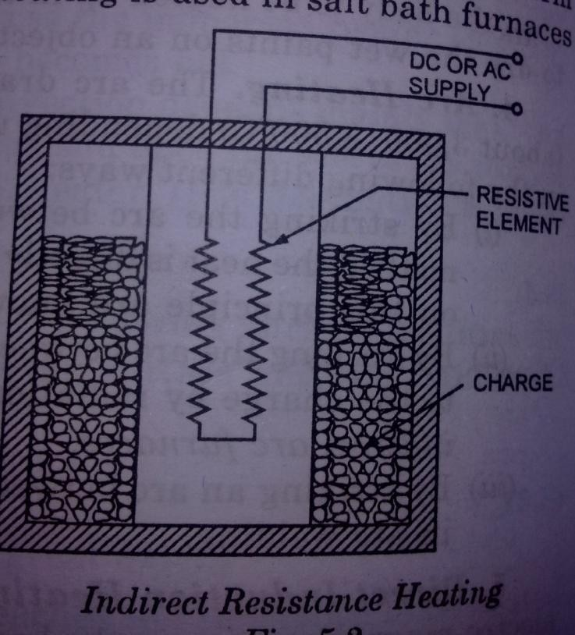
They are mainly used for the purpose of tempering, quenching and hardening of steel tools. The advantages of salt bath heating are rapidly, uniformly and selective localized heating combined with production from oxidation.
This type of furnace consists of a bath of same salt as sodium chloride and two electrodes immersed in it. When the current is passed through the electrodes immersed in salt, heat developed and temperature of salt may vary between 1000⁰c -1500⁰c depending upon type of salt used. In this Bath the material to be heated is dipped and necessary heat treatment is given to it. As d.c. would cause electrolysis of salt, therefore alternating current is used. In this method, it must be ensured that the current flows through the salt and not through the job is used.
Since the voltage required is of order of 20V, therefore a tap changing transformer is used.

Electrode boiler:
It essentially consists of electrodes and water placed in a tank. When the supply is given to the electrodes the current passes through the electrodes and water and produces heat. Heat is produced due to the resistance offered by water. The tank in which the water is placed is earthed solidly and connected to earth
D.c supply is not preferable as it results in electrolysis of water which in turn results in evolution of H₂ at negative electrode and oxygen at positive electrode. But passage of a.c. hardly results in evolution of gas, but heats the water. Thus a.c. is recommended.

Indirect Resistance heating:
In this method, the current is passed through high resistive element known as heating element which is placed either above or below the substance to be heated. The heat produced by the heating element due to I²R loss is delivered to the material to be heated by one or modes of transfer of heat. i.e. conduction or convection or radiation.
In case of industrial heating where a large amount of charge is to be heated the heating element is kept in cylindrical surrounded by the jacket containing the charge as shown

This arrangement provides a uniform temperature control can be provided in this case by presetting the time duration.
This type of heating is used in room heater, immersion heaters, in bimetallic strips and various types of resistance ovens used in domestic and commercial cooking.

Applications of Indirect resistance heating:
    - Resistance ovens:
It essentially consists of a high resistive material through which an electric current is passed placed in a chamber made of heat insulating material. The element may be in the form of strip or wire and is placed on the top, bottom of the oven depending upon circumstances.

In certain types of ovens, two electrodes project from the opposite walls of the oven and a high current is passed through these electrodes. This type of ovens is used where high temperature is desirable. The shape and size of the oven depend upon nature of the job.

Resistance ovens are used for various purposes such as heat treatment of metals, drying, backing of pottery materials, cooking of food e.t.c.
The temperature of oven (I²Rt) can be controlled by controlling (i) voltage or current (ii) time and (iii) resistance
Voltage can be varied by using tapped transformer for supply to the oven or by using series resistance so that some voltage dropped across this series resistaor.
The automatic control of temperature can be obtained by providing thermostat which will operate a switch to OFF or ON the circuit as soon as the temperature exceeds of fall below the adjusted value.
In order to control the temperature by means of resistance various series and parallel combinations are used for single phase supply and different star-delta arrangements for three-phase supply.

Immersion water heater:
Most of electric water heating is done by immersion heaters which consists of resistance coils placed in slotted cylinders of ceramic material. The material used for resistance coils is nichrome wire coated with magnesium oxide for preventing oxidation of the element which heats up the water due to I²R loss in it.

Radiant Heating or Infrared Heating:
In this method of heating, heating elements consist of tungsten filament lamps together with reflectors to direct the whole of heat emitted on to charge (material to be heated). The lamps are operated at 2300⁰c there by giving a large amount of infrared radiations and the reflectors are plated with rhodium which prevents the leakage of heat through the chamber. The lamps used are rated between 250-11,000 watts as 250V.

Radiant heating possess the fallowing advantages:
      - Rapid heating
      - Compactness of heating units.
      - Flexibility.
And this method of heating founds wide applications in
        - Drying paints of radio cabinets and wood furniture
        - pre-heating of plastics prior to moulding.
        - Softening of thermoplastic sheets.
        - Drying of pottery, paper, textiles, e.t.c.
For obtaining best results, the infrared lamps are located at a distance of 25-30 cm from the object to be heated

High frequency Heating: Induction Heating:
Induction heating is based on the principle of a.c. transformers. There is a primary winding through which an a.c. current is passed which is magnetically coupled to the charge to be heated. When an a.c. current is passed through primary heating coil, an electric current is induced in the charge and the value of the induced current is dependent on
- The magnitude of primary current.
- The ratio of number of turns in the primary and secondary circuit.
- Co-efficient of magnetic coupling.

The heat develops depend upon the power drawn by the charge and since P = therefore

to develop heat sufficient to melt the charge the resistance should be low which is possible only with metals and the voltage must be higher which is obtaining by employing higher flux since the higher the flux linked, the higher is the voltage induced. Thus magnetic materials are found to be suitable for this type of heating because of their higher permeability.
In case of charge to be heated is non-magnetic, the heat generated is due to eddy current losses whereas if it is a magnetic material there will be a hysteresis losses in addition. Eddy current loss is proportional to frequency and hysteresis loss is proportional to square of frequency and these laws holds good upto a limited temperature (curie point) since the magnetic materials lose their magnetic properties above curie temperature.
The high frequency require for induction heating is obtained from motor generator set, spark gap converter and vacuum tube oscillator.

The various factors on which the induction heating depends are
  - Magnitude of primary current I_{p} since if the primary current is high the flux is high and hence I_{s} is high and thus heat developed ishigh.
  - Frequency since hysteresis and eddy current loss depends on frequency.
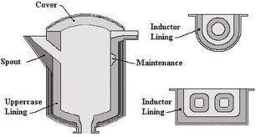
  - Reciprocal of distance between primary coil and charge because if the distance is less the magnetic coupling in more and thus heat developed is more.
  - permeability of the charge(metal) and resistivity of the charge.
Magnetic materials generally have high permeability and resistivity than non- magnetic materials and thus the induction heating is more adaptable and economical for treating magnetic materials.

Characteristics of Induction Heating:
- Current flows only on the outer surface of the metal and in doing so heats up the outer surface because if an alternating current is passed through a surface it tends to crowd at the outer surface(skin effect) because of large inductance at the centre.
- the current flow is restricted axially to that surface of the metal which is directly in plane with the primary coil and thus heat produced is restricted to that portion.
- As the heat is developed directly in side the metal which is to be heated, the the transfer of heat is very quick.
- There is no mechanical or chemical contact between the source of energy and the metal to be heated up. Thus no care is to be paid towards the connection.
- The temperature attained by this type of heating is extremely high since there is no medium as heat is produced in the metal itself.

Induction furnaces:

There are basically two types of induction furnaces:
  - Core type or low frequency induction furnace.
  - Core less or high frequency induction furnace.

Core type or low frequency induction furnace:
The furnace consists of a circular hearth in the form of trough which contains the charge to be melted in the form of annular ring. This metal ring is large in diameter is magnetically inter linked with an electrical winding energized by an a.c. source. The furnace is therefore essentially a transformer in which the charge to be heated forms a single turn short circuited secondary and is magnetically coupled to primary by an iron core. The charge is melted due to the heavy current induced in it. When there is no molten metal, no current will flow in the secondary. Thus to start the furnace, the molten metal is to be poured in the hearth.

Drawbacks of core type furnace:
  - As the magnetic coupling is between the primary and secondary is poor, since leakage reactance is high and p.f. is low. To overcome this difficulty the furnace must be designed foe a low frequency as low as 10Hz which can be achieved by using a frequency changer which involves extra cost.
  - If normal supply frequency is employed for operation of such furnaces the electromagnetic lines of force causes turbulence of molten metal and may become severe unless the frequency is kept low.
  - If the current density exceeds 5 A/m² , the pinch effect (formation of bubble) due to electromagnetic forces may cause complete interruption of secondary circuit.
  - The crucible(trough) for the charge is of odd shape and is inconvenient from metallurgical point of view.
  - For functioning of the furnace the closing of secondary circuit is essentialwhich necessitates the formation of complete ring of charger around the core.
On account of the above drawbacks, such furnaces have become absolute now-a-days.

Core Less Induction Furnace:
The eddy currents developed in the magnetic circuit is given as Eddy currents α B² F²
Where B- flux density, f- frequency
In a coreless furnace there is no core and thus flux density will be low. Hence for compensating the low flux density, the primary current applied to the primary should have sufficiently high frequency. Thus by applying current of high frequency the core of induction furnace can be eliminated there by reducing its weight and increasing the flexibility.
The furnace consists of a ceramic crucible cylindrical in shape enclosed within a coil.
Which forms the primary of the transformer and the charge in the crucible, the secondary of the transformer? The charge is put into the crucible and primary winding coil is connected to high frequency a.c supply. The flux created by primary winding set up eddy currents in the charge which flow concentrically with those in the primary winding. These eddy currents heat up the charge to its melting point and set up electromagnetic forces producing stirring action which is essential for obtaining uniform quality of metal.
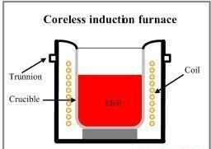

Because of high frequency employed, which is necessary to induce the required voltage in the secondary, the skin effect in the primary coil increases the effective resistance of the coil and hence copper losses tend to high and artificial cooling is necessary. Thus the primary winding coils are since made of hallow copper conductors through which cooling water can be circulated. Insulated supporting structure is employed for such furnaces as the stray magnetic field due to the current in the primary coil may induce eddy currents in the metal supporting structures there by leading to the over heating of strictures and reduction of efficiency.
The choice of frequency of primary current can be ascertained by the fallowing penetration formula in which the secondary current is assumed to be uniformly distributed over a cylindrical layer at the outside edge of the crucible and having a thickness.

Advantages:
  - They are fast in operation.
  - Precise control of power into the charge can be employed and thus uniform quality of product obtained is unattainable by any other method.
  - Absence of dirt, smoke, noise e.t.c.
  - Crucible of any shape can be used.
  - The eddy currents in the charge result in automatic stirring.
  - Erection cost of a coreless furnace is less.
  - Operation cost is also low.
  - It is possible to operate coreless induction furnace intermittently as no time is lostin warming up.

Applications:
    - These furnaces are used for production of steel and are also used for melting of non- ferrous metals like brass, bronze, copper, aluminium, magnesium e.t.c.
    - They are also used for specialized applications such as vacuum melting, duplexing steel, heating of charges of non-conducting materials by use of conducting crucibles.

Applications of induction heating:
- surface Hardening: The materials used for making parts such as spildle, saw blades, gears, axles should be hard and tough to withstand the wear which possible with induction heating since with induction heating it is possible to concentrate the heating effect to desirableportion.
- Deep hardening: With the help of induction heating, hardening of material to any depth is possible and hence this type of heating is used for deep hardening of articles such as screw driver, tools, drills e.t.c.
- Tempering: In some mechanical process, the work pieces becomes more hard than required and may need tempering to loose their hardness for tempering accurate control of heat is required which is possible only with induction heating.
- Smalting: Induction heating at high frequency is preferred for extraction of metal from ore where the process is to be carried out in some protective atmosphere or vacuum.
- Soldering; For soldering it is essential that required amount of heat is to developed at the soldering point where as the remaining portion of the solder may remain cold which can be achieved economically and efficiently by induction heating. With the help of induction it is possible to melt various metals in suitable furnaces.

High Frequency Eddy Current Heating:
In this method of heating, the machine part to be heated is surrounded by a coil through which an alternating current at high frequency is passed. The high frequency current carry coil known as the heater coil or work coil and the material to be heated is knoen as charge load. The electromagnetic field developed in the coil produces heating due to eddy current set up in the part to be heated.
Since the eddy current loss is proportional to the product of square of supply frequency and flux density.
Therefore by controlling frequency and flux density, the amount of heat can be controlled.

Induced eddy current is of greatest magnitude at the surface of material to be heated and its value decreases as we go inside the material due to the skin effect.
Since the depth of penetration of eddy currents into the charge is inversely proportional to supply frequency as given by

Therefore eddy current heating can be restricted to any depth of the material by judicious selection of frequency of heating current. This frequency employed is in range of 10,000- 400,000 Hz.
In case of magnetic material, in addition to eddy current loss, hysteresisloss also contribute of production of heat.

Advantages:
  - It is quick, clean and convenient method.
  - Amount of heat wasted is less since heat is produced in the body to be heated up.
  - Control of temperature is easy.
  - The can be made to penetrate into metal surface to any desired depth.
  - Unskilled labour can also operate the equipment.
  - The amount of heat produced can be accurately controlled by suitable timing devices.
  - With this type of heating, it is possible to heat many different objects of different shapes and sizes with the same coil.

Disadvantages:
- Generation of heat is costly.
- Efficiency of equipment is quite low.
- Initial cost of equipment is quite high.

Applications:
- The high frequency eddy current heating is used for surface hardening in which the desired depth of penetration of heat can be obtained by judicious selection of frequency which reduces the cost, labour and time considerably.
- This method is employed in annealing of metals which saves a lot of time along with the prevention of scales on metals obtained by conventional methods.
- Eddy current heating can be economically employed for soldering precisely for high temperatures.
- This method of heating is also used for welding, drying of paints, melting ofprecious metals, sterilization of surgical instruments and forgoing of bolt heads and river heads.

Dielectric Heating:
When non-metallic metals i.e. insulators such as wood, plastic, china glass, ceramics e.t.c. are subjected to high alternating voltage their temperature willincrease after some time. This increase in temperature is due to the conversion of dielectric loss to heat. The material to be heated is placed as slab between the metallic plates or electrodes connected to high frequency a.c. supply.
Dielectric loss is depend upon the frequency and high voltage therefore for obtaining adequate heating effect high voltage at about 20 Kv and frequency of about 10-30 MHz are usually employed. High frequency is obtained from valve oscillator.
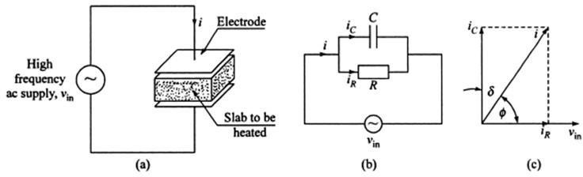
The current drawn by the capacitor when connected to an a.c. supply voltage does not lead the supply voltage by exactly 90⁰ since it is not possible to get a pure capacitor and there is always some resistance due to which heat is always produced in the dielectric material placed in between the two plates of capacitor. The electric energy dissipated in the form of heat energy in dielectric material is known as dielectric loss.

Advantages:
  - If the material to be heated is homogeneous and alternating electric field is uniform, heat is developed uniformly and simultaneously throughout the entire mass of charge.
  - As material to be heated is non-conducting, therefore with the help of other methodsof heating is not possible to heat the material.

Applications:
The cost of the equipment required for dielectric heating is so high than it is employed where other methods are impracticable and too slow. Some of the applications of this type of heating are:
- synthetics: The raw materials called plastic performs used for synthetics are required to be heated uniformly before putting them in hot moulds so that the whole mass becomes fluid at a time, otherwise if the raw material is put directly in the moulds usually heated by steam the outer surface of the perform will become hot and starts curing while inner surface does not reach the fluid temperature there by resulting in unequal hardening of plastic.
- Diathermy: Dielectric heating is employed for heating tissues, and bones of body required for the treatment of certain types of pains and diseases.
- Sterilization: Dielectric heating is quite suitable for sterilization ofbandages, absorbent cotton, instruments e.t.c.
- Baking of foundary cores: Dielectric heating is more suitable foe baking foundary cores where thermo setting binders are employed as they set instantaneously when brought to polymerizing temperature.
- Textile industry: In textile industry, dielectric heating is employed for drying purpose.
- Food processing: The dielectric heating for food processing is one of the most modern method and set fourth such processes which are outside.

The dielectric heating is used for;
- Heating of general processing such as coffee roasting, chocolate industry.
- Cooking of sea foods such as oysters without removing the outer shell.
- Dehydration of fruits, milk, cream and eggs.
- Defrosting of frozen foods such as meat and vegetables.
- For control of bacterial growth and production of germicidal reactions, the food product are heated and to prevent the product losting the flavor, they are dielectric heated.

Advantages of High frequency heating( Dielectric, Induction, Eddy current):
High frequency equipments are very costly but are preferred due to the fallowing advantages:
- The quantity of heat can be accurately controlled with the help of electric clocks which are function of frequencies as they are run by synchronous motors.
- The working atmosphere is free from flue gases, smoke and dirt.
- The equipment used is compact and hence the space required is less.
- It is easy to maintain high frequency equipment.
- Operation of high frequency equipments is easy and does not required skilled labour.
- As the heat is developed in the material to be heated, loss of heat is less.
- High frequency equipment can be made automatic.
- Non-conducting materials can be economically heated by high frequency heating (Dielectric) which is not possible with other methods.
- Heat provided by high frequency methods is uniformly and evenly distributed.
- The quality of product obtained by these methods is improved.

